Bitcoin Case study

Table of Contents

Introduction 1

Understanding Bitcoin 1

Bitcoin Issues 2

Comparisons 2

Conclusion and recommendations 3

Figure 1 3

Figure 2 4

Figure 3 4

Bibliography 5

## 

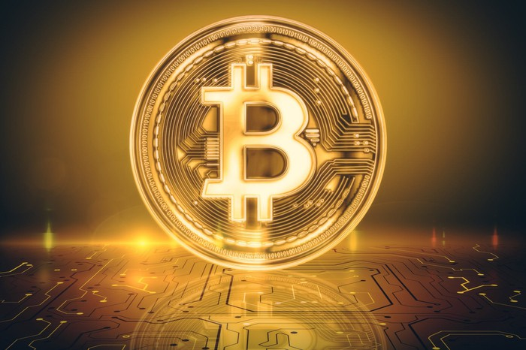

## Introduction

In this case study there has been in-depth research undertaken to investigate how Bitcoin (BTC) has disrupted traditional finance using technology to develop modern day finance. It will analyse the issue with traditional centralised banking and compare the benefits of digital currency. Lastly it will ask the question could BTC serve as an alternative to fiat currency? Bitcoin is hot on everyone's lips in 2021 after BTC's 3rd halving event it has recently seen an all-time high of $69,045. This peer-to-peer technology and decentralized system created by an unidentifiable founder, Satoshi Nakamoto, has revolutionised how people perceive money. Furthermore, it has provided people with freedom to question centralised banks and fiat currency.

## Understanding Bitcoin

The disruption of traditional finance is Bitcoin, due to its adoption of technology and computer power. Investopedia defines it as " A digital currency, a decentralized system that records transactions in a distributed ledger called a blockchain." (Investopedia, 2021). This software run on a protocol called the blockchain. Every blockchain consists of an individual chain of blocks arranged chronologically. Transactions in Bitcoin are acceptable to the 100th million part. This decimal place is known as a Satoshi, in honour of the creator. These transactions take place on the Peer-to-Peer network. This is a decentralised network communications model that consists of a group of nodes. These nodes collectively store and share files where each node acts as an individual peer. Importantly, these nodes communicate without any central administration which gives them all equal power and so they perform the same tasks. In comparison traditional banks use Traditional Client-Server Systems that have a dedicated server and specific clients, whereas in P2P, it is maintained by a distributed network of users, where each node can act both as a server and a client. P2P is a technology that is based on a very simple principle, and that is the concept of decentralization. The peer-to-peer architecture of blockchain allows all cryptocurrencies to be transferred worldwide, without the need of any middle-man or intermediaries or central server.

## Bitcoin Issues

Could Bitcoin disrupt central banks enough to become a currency?  The present issue with using Bitcoin for payment transactions is the issue of network scalability. When transactions take place, each node must verify the transaction and the network can only process up to 7 transactions a second. Which in the grand scheme wouldn't be able to keep up with every person in the world. In contrast VISA alone claim to handle 65,000 transactions a second. Bitcoin is more seen as a store of value something that mimics Gold rather than an alternative to fiat currency. With its scarcity that is hard to obtain and even harder to produce. There will only ever be 21 million Bitcoin and after 2140 there will be no more created. Therefore, Bitcoin is the only liquid asset in the world that has a fixed supply. Furthermore, with the halving events Bitcoin is disinflationary.

While the peer-to-peer network creates great security. At this current time Bitcoin is still a speculative asset. The asset will struggle to uphold the stability and transactability of fiat and a bank in this current environment. The spectacular volatility is unsuitable for a central bank. Many crypto advisors dubiously speculate that there's a 4-year cycle where BTC halving is believed to be in the middle. that lengthens each time. After the halving BTC tends to have a "Bull Run". The price of BTC exponentially increases, following it then goes into a bear market where the market sees fear and people sell erratically which causes the price of BTC to crash. This is represented clearly in figure 1, in October BTC comes out of accumulation phase and the market pumps and less than six months later the market crashes. This kind of volatility isn't something a central bank could afford to have. Eswar Prasad sums it up well in an interview with CNBC, "“So you could take a bitcoin to a store and one day, get a cup of coffee and another day, with the same bitcoin, be able to treat yourself to a lavish meal. So that doesn’t work well for the medium of exchange,” (CNBC, 2021).

## Comparisons

## 

Bitcoin isn't the only digital currency disrupting traditional finance. There have been many attempted projects to replicate Bitcoin. In 2019 according to coinopsy there was already 1085 dead coins*. These coins share many similarities to Bitcoin’s framework including the process of mining block being peer to peer and transactions through the block chain. Bitcoin main competitor is Ethereum which has a market capitalization of 510 billion. Ethereum has more use cases in society with developers being able to use the block chain to create smart contracts and decentralised apps. These 2 digital assets are clear leaders in the asset class with BNB hovering around 100 billion market capitalization and Solana, Cardano and XRP all between the 65-50 billion market cap. These other digital assets have subsequently built out the digital asset ecosystem and provided more infrastructure which intern has widened the market. For instance, non-fungible tokens developed on Ethereum have attracted a younger market. Although at this stage it seems Bitcoin will not be dethroned as the leading cryptocurrency as it currently has a market capitalization of $1,127,128,945,218 in comparison the total market capitalization excluding Bitcoin hovers around the $1.14 trillion. (Refer to figure 2&3).

## Conclusion and recommendations

It's proposed that BTC hardforks to create more scalability as a network needs to demonstrate its ability to process transactions without any issues or delays. To scale up this would also benefit the network in increasing capacity and size which consequently improves security. Secondly, it's recommended that the network provides sufficient rewards to the miners to keep the eco system competitive and the miners motivated. In conclusion Bitcoin has disrupted finance in an astounding manner and is something that everyone should be exposed to. It has used technology and software to create security and a disinflationary store of value. Therefore, it's hypothesised that BTC could one day serve as a central bank but it's highly unlikely that it becomes the leading global currency.

### Figure 1

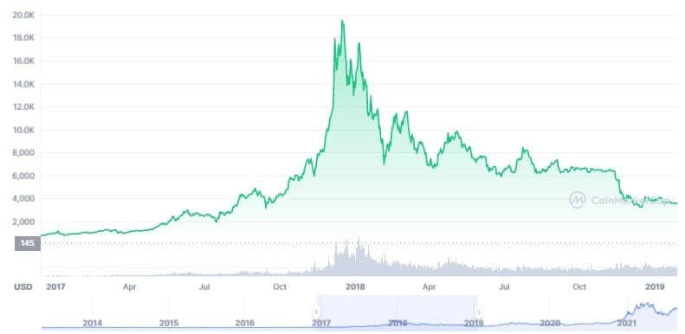

### Figure 2

### Figure 3

# Bibliography

1. *The Bitcoin and Crypto Market Cycles: What You Need to Know* 2018b, CryptoPotato.
2. Sharma, TK 2020, *Blockchain & Role of P2P Network*, Blockchain Council.
3. EBR, E 2020, *Top 5 Advantages of Bitcoin over Fiat Currency*, The European Business Review, viewed 17 November 2021, <https://www.europeanbusinessreview.com/top-5-advantages-of-bitcoin-over-fiat-currency/#:~:text=Low%20storage%20and%20transfer%20cost>.
4. *Can Bitcoin Kill Central Banks?* 2019, Investopedia.
5. *Crypto vs Banking System - Innovation & Technology Blog* 2019, ZIGURAT Innovation School - Transform the way you do business!
6. *Bitcoin will never replace the dollar, claims CPA* n.d., Information Age, viewed 17 November 2021, <https://ia.acs.org.au/article/2021/bitcoin-will-never-replace-the-dollar--claims-cpa.html>.
7. Frankenfield, J 2021, *Bitcoin*, Investopedia.
8. *Crypto Total Market Cap Chart — TradingView* 2019, TradingView, TradingView.
9. Bitpanda n.d., *The problem of scalability in the Bitcoin network*, www.bitpanda.com.
10. Munster, B 2020, *Why Bitcoin is a superior store of value*, Medium.
11. *25 PayPal Statistics & Facts for 2021* 2021, Balancing Everything, viewed 17 November 2021, <https://balancingeverything.com/paypal-statistics/>.